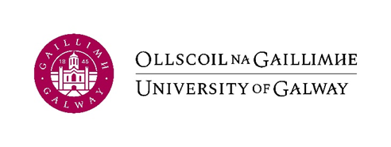

ERASMUS+ Certificate of Attendance
2023/2024

(To be completed by the host university at the end of the study period abroad)

This certificate confirms that:
(Name of Student) ____________________________

from University of Galway
attended
(Name of Host University) ______________________
as an Erasmus+ student from
(start date) ____ / ____ / 20___
(the date the student began his/her studies [OR an induction/orientation programme OR a language course], not merely the date of arrival)
to
(finish date)* ____ / ____ / 20___
(the date the student finished his/her studies or exams - please do not include an extended stay for leisure purposes.)
*The “finish date” given above should not be more than 3 days after the date on which this document was signed (below).

The dates shown should be those of the individual student’s REAL ATTENDANCE at your university, not merely the official semester dates.
Name and function: ___________________________
Signature: ___________________________________
Date: _________________

Stamp of Host University:

Please return by email (in PDF format) to outgoingerasmus@universityofgalway.ie

