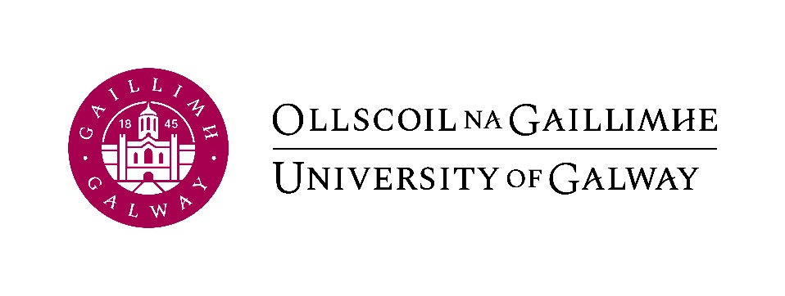

Ranganna Comhrá Gaeilge don Fhoireann 2023-2024

*Bloclitreacha (Block Letters)

*Sloinne (Surname): ____________________________________________
*Céadainm (Name): _______________________________________
Rannóg (Department): _______________________________________
Uimhir Foirne (Staff Id.): __________
Folíne (Extension): _________ Fón Póca (Mobile) : __________
R-phost (E-mail address):

Clárú (Registration): Ní mór clárú ar líne roimh Dé Céadaoin 10 Eanáir
2024/You must register before Wednesday 10th January.

Dáta (Date): Ranganna Gaeilge na Foirne ag tosú an tseachtain dar tús 15 Eanáir 2024/Classes will commence week beginning 15th January 2024.

Ionad (Venue): ar líne/online

Seol an fhoirm chomhlánaithe chuig evan.ogriofa@ollscoilnagaillimhe.ie

Send this completed application form to evan.ogriofa@ollscoilnagaillimhe.ie

Don oifig amháin
Toradh TST: ______

Leibhéal: _________

